**EXC200** **Item** **Setting** **Guide**

1. **Reaction curve explanation**

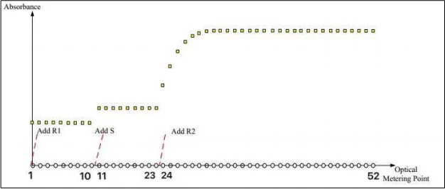

Instrument adds R1 at the beginning of test, adds sample between 10th point and 11th point, adds R2 between 23rd point and 24th point. This is the fixed setting of instrument hardware design, so unable to change.

1. **Blank time setting.**

**PS**: You only need to set blank time in end-point method.

**2.1 One-point end-point method.**

Measure the absorbance before adding sample as the base absorbance, please select extra couple of points in order to avoid the unstable shaking points.

Recommend blank time: 7-9.

**2.2 Two-point end-point method.**

If measuring the absorbance before adding R2 (R2 point is 23-24) as the base absorbance,

recommended blank time: 20-22.

If measuring the absorbance after adding R2 (R2 point is 23-24) as the base absorbance,

recommended blank time: 24-25.

### Reaction time setting.

**3.1 End-point method.**

Record the absorbance after reaction is finished (the last point is 52), record couple of extra points to calculate the average absorbance in order to avoid unstable shaking points.

Recommended time: 48-51.

**The** **reaction** **curve** **of** **single** **reagent** **looks** **like** **the** **following** **diagram** **for** **reference.**

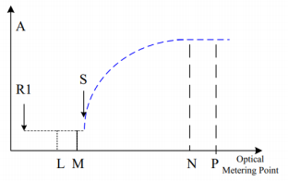



L M N P

L-M is recommended 7-9. N-P is recommended 48-51.

**The reaction curve of dual reagent looks like the following diagram for reference.**

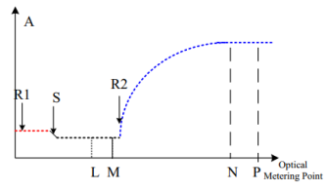



L M N P

1. M depends on whether it is before or after adding R2, as is shown in part 2.2.

N-P is recommended 48-51.

**3.2 2-point (fix time) method.**

**PS**: Blank time is unnecessary, which means you can keep the value box blank.

Record the absorbance of point N since the reaction step into a relatively linear area, and record the absorbance of point P in a couple of minutes later. IFU will show the delay of point N measurement after the reaction starts, and the interval time between two absorbance measurement shows the interval between point N and point P.

**The reaction curve of single reagent looks like the following diagram for reference.**

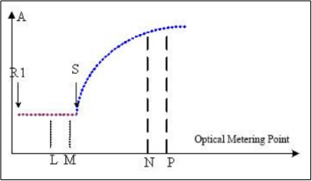

**The reaction curve of dual reagent looks like the following diagram for reference.**

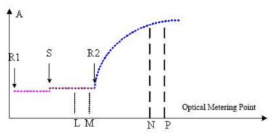



**empty empty N P**

N: $$\frac{delay time(seconds)}{22.5 seconds}+last adding reagent(point)$$

For single reagent, last adding reagent(point) is 11, when the instrument has added the sample.

For dual reagent, last adding reagent(point) is 24, when the instrument has added the reagent 2.

P: $$\frac{interval time(seconds)}{22.5 seconds}+N$$

For instance:

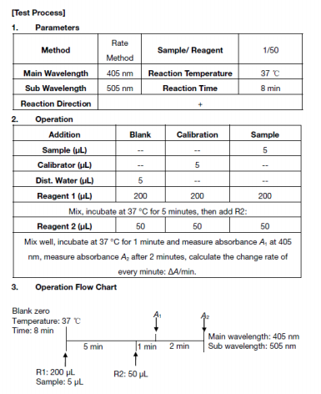

Explanation: Mix R1, sample and R2 first, then wait 1 minute for reaction, so delay time is 1min. Measure A2 in extra 2 mins later after measuring A1, so interval time is 2 mins. Typical 2 points method.

Blank time as recommended: none

Reaction time for dual reagents:

N= $\frac{1min}{22.5 seconds}+24≈27$ point

P= $\frac{2 min}{22.5 seconds}+$ 27 $≈33 point$

The reaction time is recommended 27-33.

**3.3 Kinetic method (rate method).**

Kinetic method will monitor the absorbance of every point between point N and point P, to monitor the absorbance change rate between every 2 points dynamically. Normally applying for activity monitoring of enzyme.

IFU will show the delay of point N measurement after the reaction starts, and the interval time between two absorbance measurement shows the monitoring time between point N and point P.

**The reaction curve looks like the following diagrams for reference.**

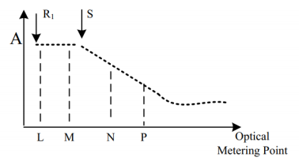

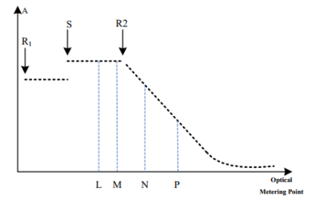



**empty empty N P**

N: $$\frac{delay time(seconds)}{22.5 seconds}+last adding reagent(point)$$

P: $$\frac{monitoring time(seconds)}{22.5 seconds}+N$$

For instance:

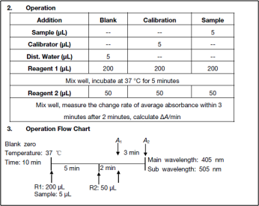

**Explanation:** Mix R1, sample, R2 first, and wait 2 mins for reaction, so delay time is 2mins, then start to measure the change rate of the next 3 mins, it means measure each point in the next 3 mins, so monitoring time is 3 mins. ‘change rate, keep monitoring, average absorbance’ are the key words for kinetic method.

Blank time as recommended: none

Reaction time:

N= $\frac{2 mins}{22.5 seconds}+24≈30$ point

P= $\frac{3 mins}{22.5 seconds}+$ 30 $≈38 point$

The reaction time is recommended 30-38.